
KOVE activities & events November - January 2024

Keep the dates - We need to hear from you at the steering group, 1.30pm Thursday November 30. Join in placard making sessions from 26 October and bring family & friends to our biggest ever toilet demand on Kilburn High Road, November 18. Please note walk changes in December. Our concert is courtesy of local group The Fortunes. We have a seasonal party provided by the Hampstead Court Care Home with great hospitality.
BENCH to BENCH supported walk: 1st Wednesdays, 1.30pm. Gentle walk, start at bench outside Kilburn Grange Park/Kilburn High Road entrance opposite Kiln Theatre. Contact Lynda on 07773 267505 or email chair@kove.org.uk. Longer walks BENCH to BENCH Kilburn and Bench to Bench London are on Wednesdays with a leader and co-leader. Check for details – start times may vary. Contact Alexandru Sones-Dawkins on 07851 136753 or alexandrusonesdawkins@gmail.com for information.
Could you be a Walk Leader? If you are interested in receiving training to volunteer on our Bench to Bench and longer London walks, please contact Lynda or John for more info.
Grand Union Canal Walk, August 2023
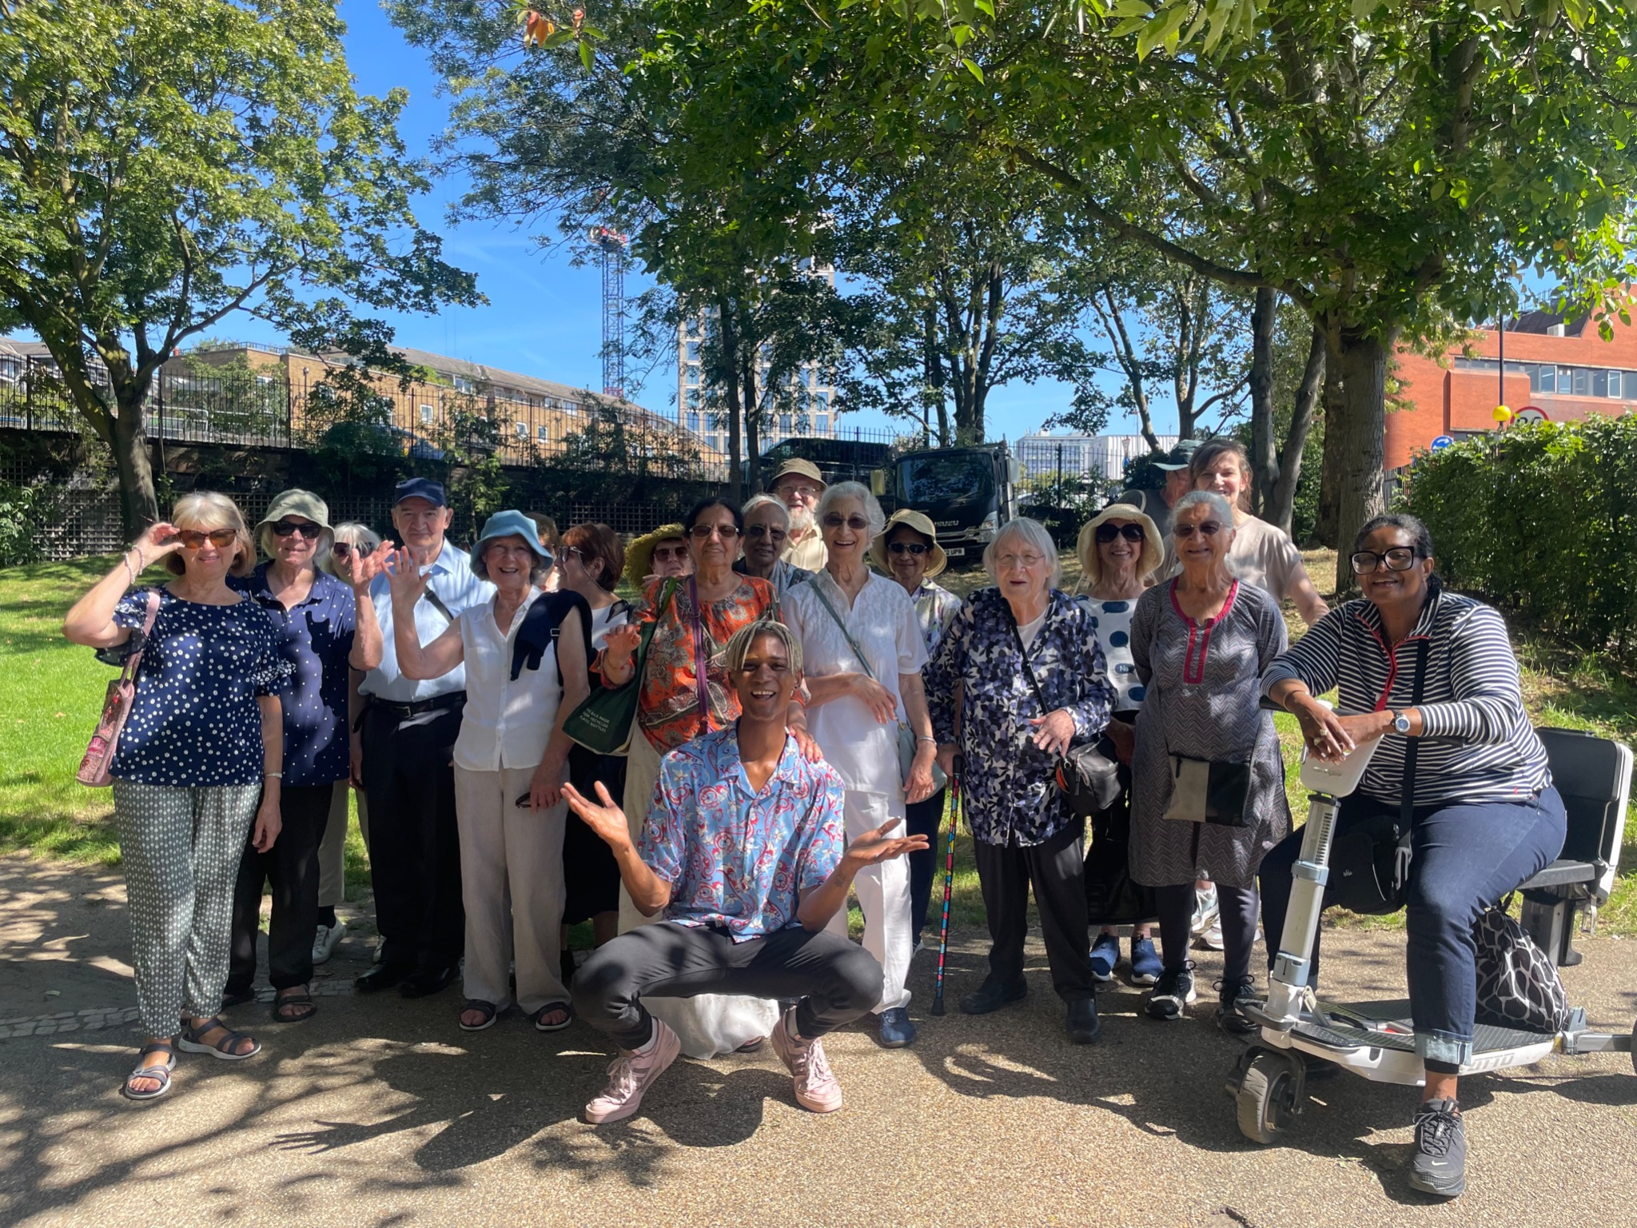
KOVE FORUM meets 11am 1st Tuesdays, Kiln Theatre, Kilburn High Road. Join us for our monthly get together - have a discussion on development and interests.
Join us for ACTIVITIES, CAKE and a CUPPA at 11am on the 1st & 3rd Fridays at Sidings Community Centre, 150 Brassey Road, NW6 2BA. (Both the Kiln and Sidings are drop-ins – no need to book - contact Lynda for more information.)
Kilburn & West Hampstead Pensioners meets monthly generally on the 3rd Thursday, 1.30pm at Sycamore Community Hall, 29 West End Lane, NW6 4NY. For information about forthcoming events contact Peter Lush: 07973 845285 or email peter56nw@outlook.com
REEL KOVE is back, register your interest with John Miles to make KOVE films 07817424356 or johnmiles68@yahoo.com
If you no longer wish to receive this bulletin, please let us know. Check out our documentary film archive https://koveweb.wordpress.com. Enquiries email: chair@kove.org.uk 07778 145787 Post c/o 54-56 Phoenix Road, NW1 1ES
Nov | Wed 1 | Supported walk | 1.30 pm Kilburn Grange Park, seat on KHR
 | Thurs 2 | REEL KOVE | (Register beforehand) Sycamore Hall
 | Fri 3 | Activities | 11.00am Sidings Centre. Relax, games + card making.
 | Mon 6 | Brent Women | 4.00pm Free cinema. Kiln, 269 Kilburn High Road
 | Mon 6th | Toilet placard making | 1-3pm Metroland Studios (behind Kilburn market|) Sessions cont. Mon 13th, 1-3pm, Tues 14th, 11-1pm
 | Tues 7 | KOVE forum | 11.00am Kiln Theatre, get together
 | Wed 8 | Mapledown Park Walk | 1.30pm Kilburn Station (Jubilee Line)
 | Wed 15 | NEW ICMP Studio | 1.30pm Queens Park Station. Tour of new music college
 | Thurs 16 | Pensioners Meeting | 1.30pm Sycamore Hall
 | Fri 17 | Activities | 11.00am Sidings Centre. Relax, games + card making.
 | Sat 18 | TOILET PROCESSION | 2.00pm Kilburn Library (Kilburn High Road)
 | Wed 22 | Docklands walk | 1.00pm West Hampstead Overground
 | Fri 24 | KOVE Concert | 11.15am arrive for 11.30am concert at Sidings Centre
 | Mon 27 | Free Movie Club | 1.30pm ‘Operation Mincemeat’ Sycamore Hall
 | Thurs 30 | Steering Group | 1.30pm Sycamore Hall
Dec | Fri 1 | Activities | 11.00am Sidings Centre. Relax, cuppa, fun + games.
 | Tues 5 | KOVE forum | 11.00am Kiln Theatre, get together
 | Wed 6 | Bench to Bench walk | Details TBC
 | Wed 13 | Seasonal Party | 1.00pm arrive for 1.30pm start, Avery, Boundary Road
 | Thurs 14 | Pensioners meeting | 1.30pm Sycamore Hall. Christmas tea + boccia
 | Fri 15 | Activities | 11.00am Sidings Centre. Relax, cuppa, fun + games.
 | Tues 19 | Move at Movies SHOW | Time TBC, Kiln Theatre
Jan | Tues 2 | KOVE forum | 11.00am Kiln Theatre, get together
 | Wed 3 | Supported walk *** | 1.30pm Kilburn Grange Park, seat on KHR
 | Fri 5 | Activities | 11.00am Sidings Centre. Relax, cuppa, fun + games.
 | Wed 10 | Bench to Bench walk | Details TBC
 | Wed 17 | West End Lane Walk | 1.30pm W Hampstead Thameslink - New developments
 | Thurs 19 | Pensioners Meeting | 1.30pm Sycamore Hall
 | Fri 20 | Activities | 11.00am Sidings Centre. Relax, cuppa, fun + games.
 | Wed 24 | Highgate Ponds | 1.30pm Brondesbury Station
 | Mon 29 | Movie Club | 1.30pm Butch Cassidy & Sundance Kid Sycamore Hall

