KOVE Annual General Meeting 24 10 2024 report
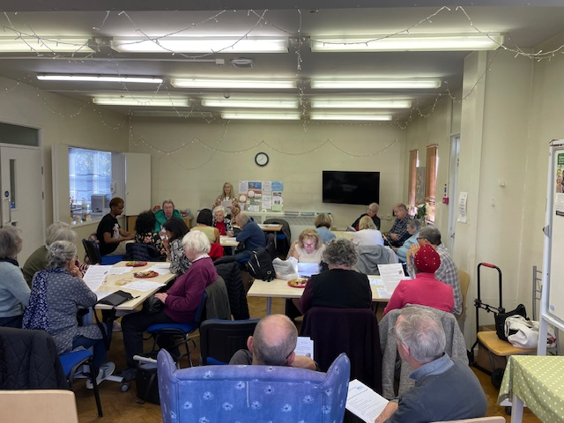
31 people came together for our AGM in Sycamore Hall on Thursday afternoon October 24th. KOVE veteran Phyllis Young, now living in a residential home in Kilburn, stood down from the Board. Her fellow-trustees Frances Eley, John Miles, Farhan Samanani and chair, Lynda Stuart, were reaffirmed. The Chair’s wide-ranging report on the year’s activities was enthusiastically approved. The Treasurer’s warnings about the state of KOVE’s finances in the year ahead were respectfully noted but not allowed to dampen the mood or weaken the commitment to a more age-friendly neighbourhood. Lynda was applauded for coordinating an extraordinary fund-raising effort. KOVE’s latest imaginative publication Take A Seat!, presented by bench-master Mel Wright, was well received. Administrator Alexander Sones-Dawkins introduced his new film about our successful delivery of a temporary toilets scheme in Kilburn Grange Park over the summer. Sasha Khan (for Camden Council) and Michael Stuart (for KOVE) highlighted the high level of public support for the project and explained the negotiations under way to restore a permanent facility. Several people hoped it can be at the changing rooms by the High Road. Lynda was applauded for coordinating an extraordinary fund-raising effort. Carlisle Cleaning Services whose generosity made the scheme function were thanked in their absence. Another new working partner of KOVE, Tim Woolford from Avery Healthcare, attending for the first time, expressed his support for our campaigns - and came with gifts!
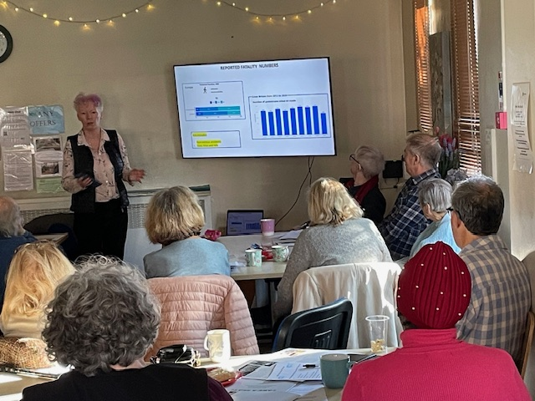

Orla Fahey, who is completing her Phd at the Royal College of Art, was the guest speaker. She described her closely-observed research into the way roads have been reconfigured to create ‘shared spaces’ for cyclists and pedestrians. She has established that these have been introduced without proper consideration for vulnerable groups and showed how they frequently don’t work, making travel less safe. Some street-planners have been impressed by her work and contributions from the floor indicated how much her concerns was shared. KOVE hopes to do further work with Orla in the future.
Looking ahead, John Miles identified the challenges facing KOVE’s volunteers and tiny staff team. A three-year plan is in development which we hope will find more favour with funders than our efforts during the last twelve months. KOVE remains open to anyone who wants to get involved with our research and development. Thanks to everyone who joined us on this successful and enjoyable afternoon.

